Running Portfolio Workbook

Mama Mia’s Accounts Payable

John Wensink

MIS350 Information Systems Analysis and Design

Dr. William Willette

April 28, 2018

Mama Mia’s ERDs

For this week’s assignment, I have created an “Entity-Relationship Diagram” (ERD) as well as a “Physical Database Model” (PDM.) In the ERD I have modeled the flow of a new order from conception to delivery. Shipping invoices are audited and either approved for payment or rejected. An inventory management system is also operated thru accounts payable as this department will have the most up to date information with the new information system. The PDM incorporates all of the elements of the ERD into tables with single value attributes paying attention to the primary keys of the ERD. The PDM also includes derived attributes from the entities they represent. The ERD has primary keys in **bold** and foreign keys in *italic.* The PDM has underlying entities highlighted in dark orange whereas the derivative attributes are highlighted in light orange.

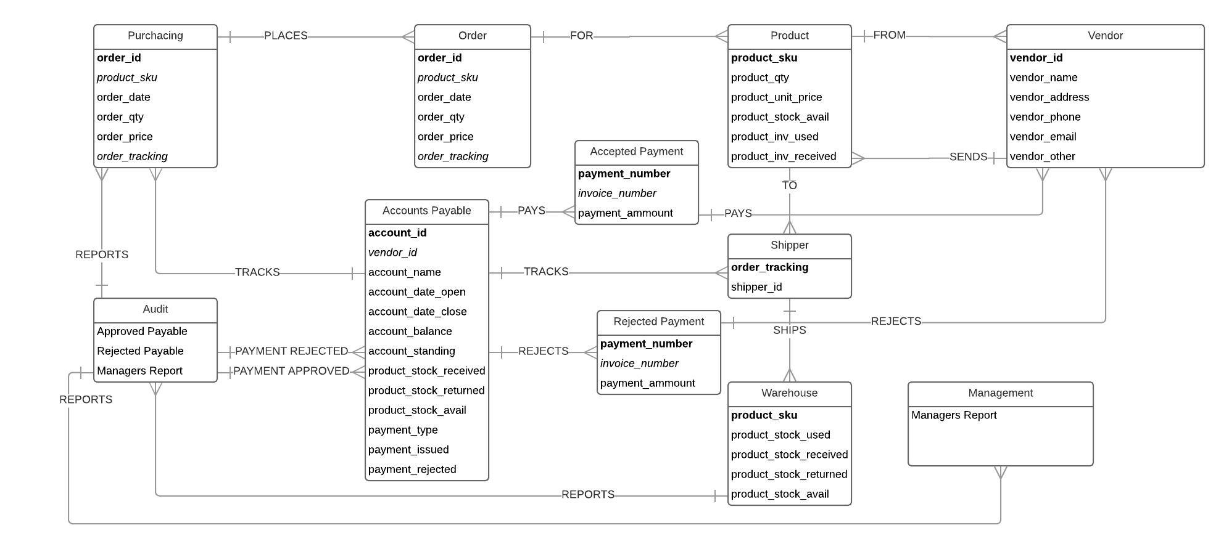

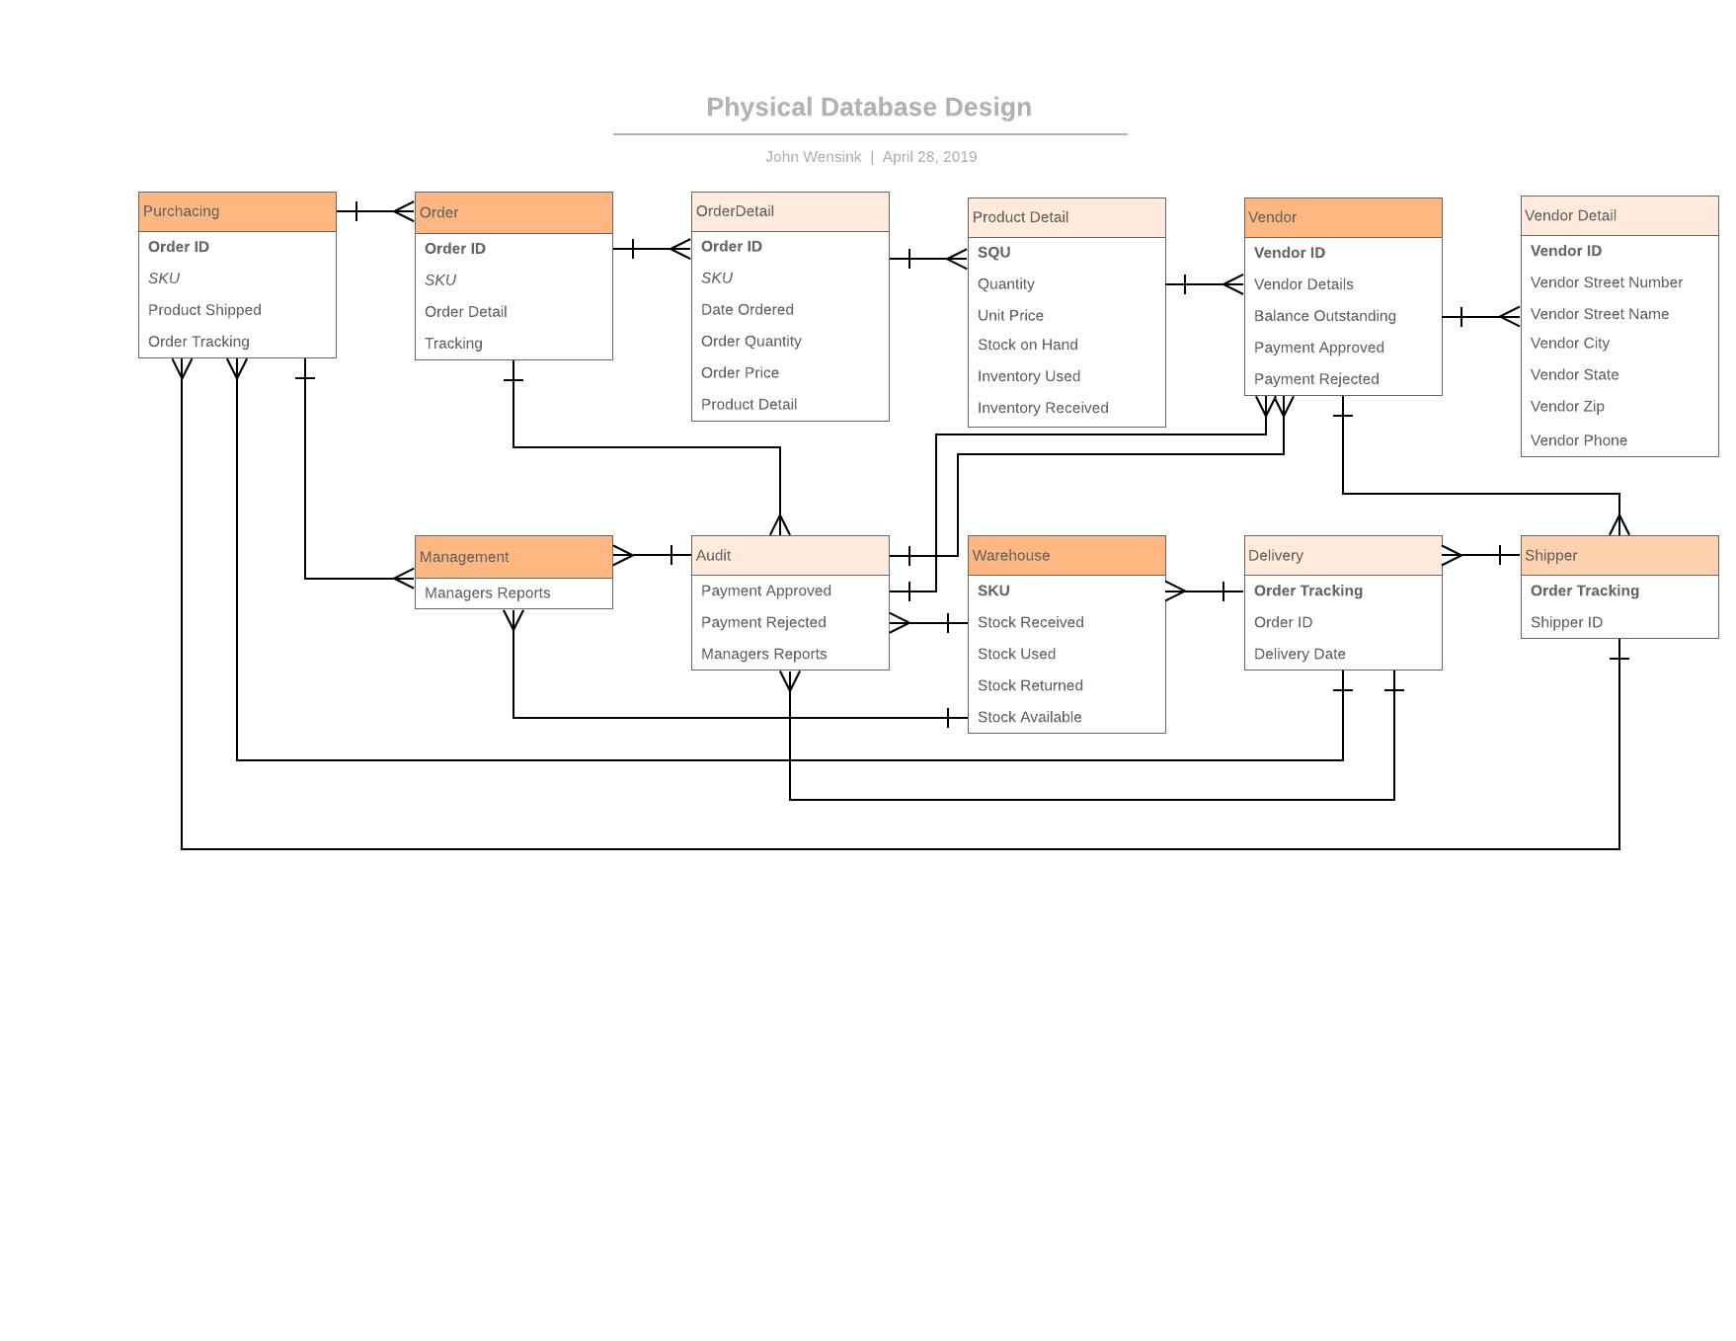

References

CSC Villanova. (n.d.). Chapter 4 Normalization. Retrieved April 28, 2019, from <http://www.csc.villanova.edu/~mdamian/Past/databasefa13/notes/ch04-Normalization.pdf>

Khabbazi, Reza, M., & Sulaiman. (2015, June 30). Inventory System and Functionality Evaluation for Production Logistics. Retrieved April 28, 2019, from <http://www.diva-portal.org/smash/record.jsf?pid=diva2:829207&dswid=-1923>

Valacich, J. S., & George, J. F. (2017). Modern Systems Analysis and Design (8 ed.). Boston: Pearson. Retrieved April 28, 2019, from <https://platform.virdocs.com/r/s/0/doc/244063/>

Visual Paradigm. (n.d.). Conceptual, Logical and Physical Data Model. Retrieved April 28, 2019, from <https://www.visual-paradigm.com/support/documents/vpuserguide/3563/3564/85378_conceptual,l.html>